Chapter 8 Special relativity
Chapter Test Answers Total marks 41
A data sheet with appropriate physics constants will be provided for this test.
Question 1
For changes in velocity measured in two different frames of reference to be the same, what must be true for the frames of reference? What name is given to this type of frame of reference? (2 marks)

Description | Marks
The frames of reference must be moving at constant velocity. | 1
They are known as inertial frames of reference (or Galilean frames of reference). | 1
Question 2
a Galilean relativity states there is no absolute velocity; rather, all velocities are relative. Using an example, explain what this means. Your example should use numerical values. (3 marks)

Description | Marks
The idea of no absolute velocity means the value of an object’s velocity will vary depending on the frame of reference from which it is observed. | 1
Example such as the following provided:  A person standing by the side of the road measures that a car is travelling at 50 km h⁻¹ but for a cyclist travelling at 15 km h⁻¹ in the same direction as the car, the car will appear to travelling at  35 km h⁻¹. | 2

b How does special relativity differ to Galilean relativity in respect of velocity?
(1 mark)

Description | Marks
In special relativity, the speed of light is the same in all frames of reference but according to Galilean relativity its speed should vary with the frame of reference. | 1

Question 3
The second of Einstein’s postulates in the special theory of relativity states that speed of light is a constant, independent of the motion of the light source or the observer. In other words, the speed of light is always 3 × 10⁸ m s⁻¹.
Explain what this implies in terms of space and time. (2 marks)

Description | Marks
This implies that space and time are not fixed.  - Time passes differently in one frame of reference compared to another.  - Distance measured in one frame of reference is different from that measured in another. | 1  1
Question 4
Two spaceships are travelling past Earth side by side at the same high velocity. The captain of the first spaceship sends a radio signal (hence it is travelling at c) to the captain of the second spaceship. The captain of the second ship then sends a return signal. This situation is illustrated below.
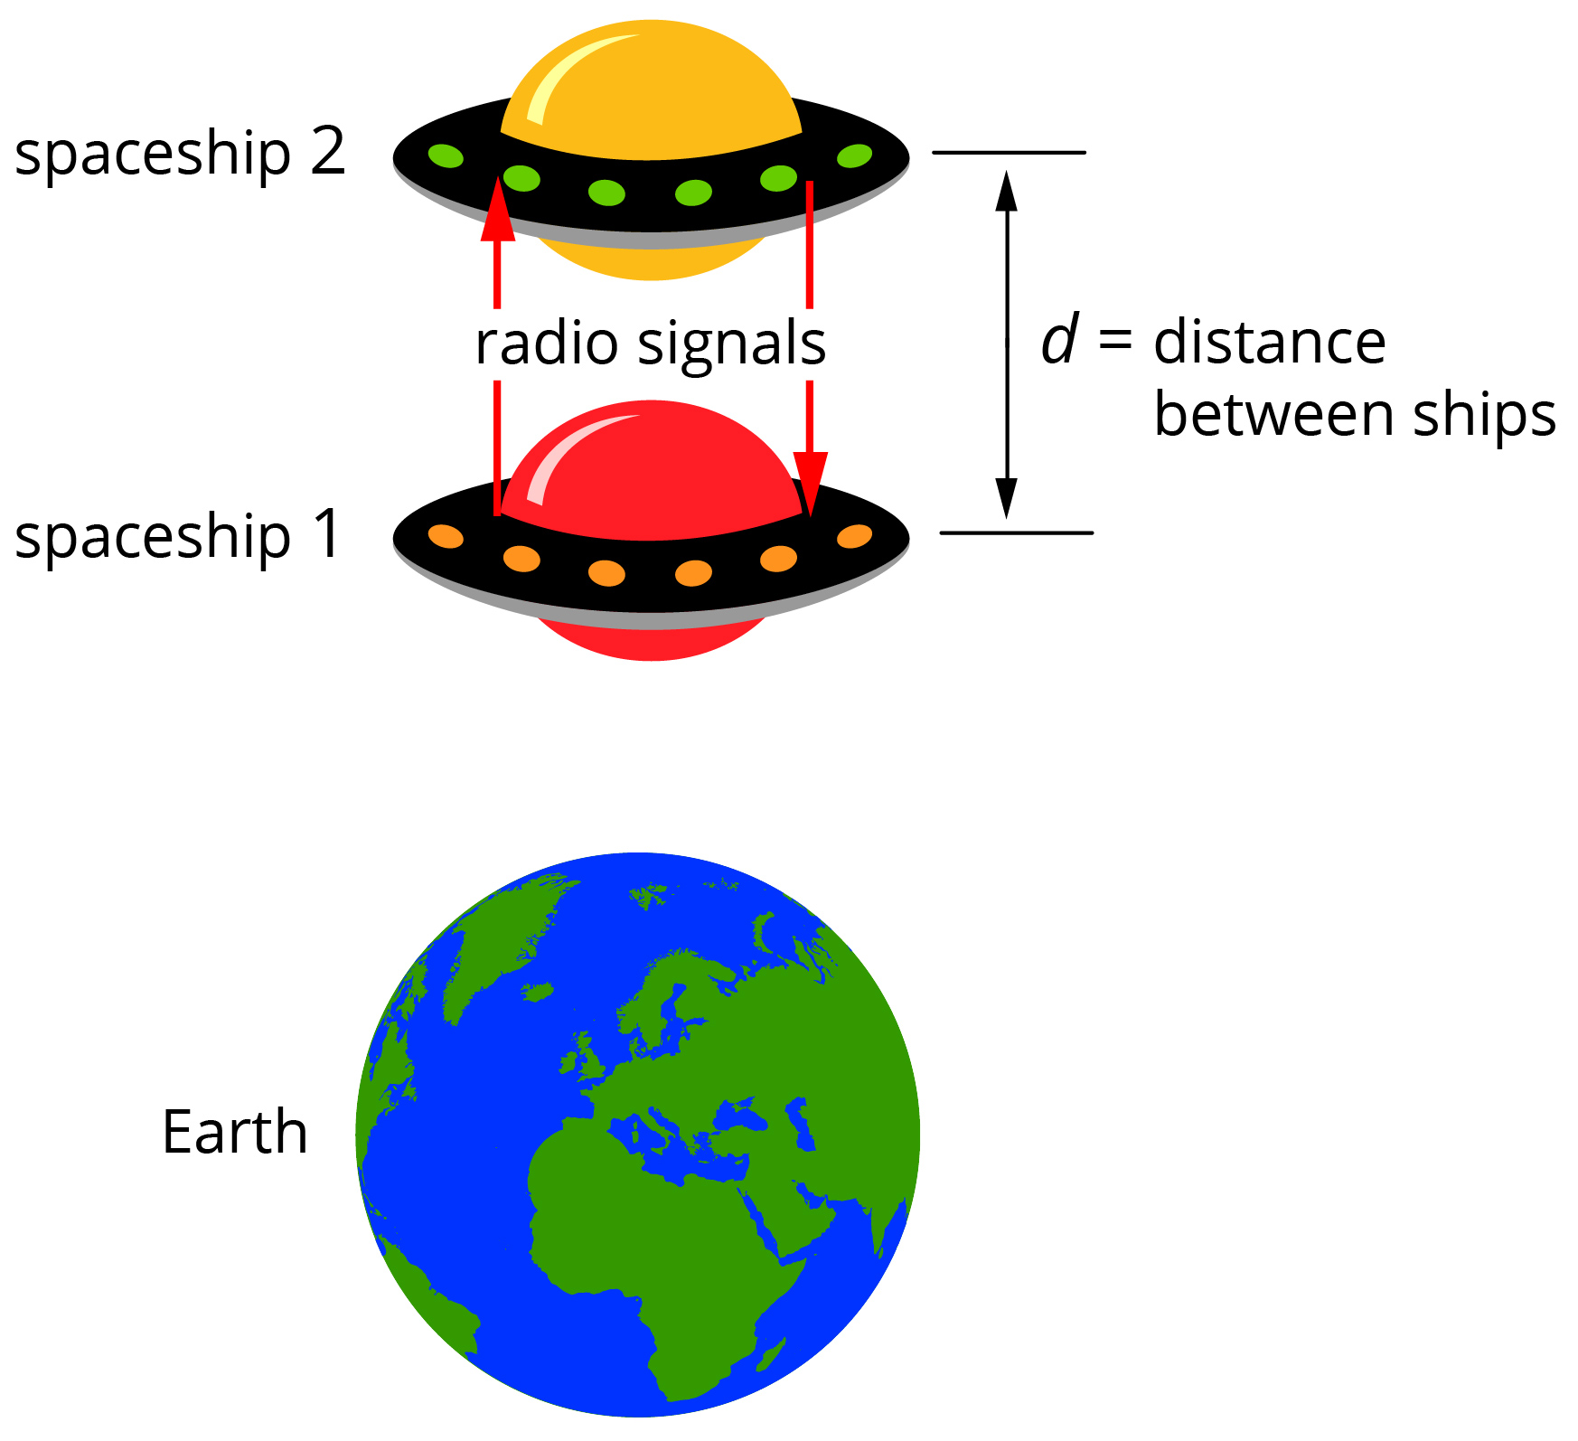
The captains of the spaceships record the time for the signals to pass between them as less than what an observer at the space command centre on Earth records. With the aid of a labelled diagram and a supporting description, explain this apparent contradiction.
(5 marks)

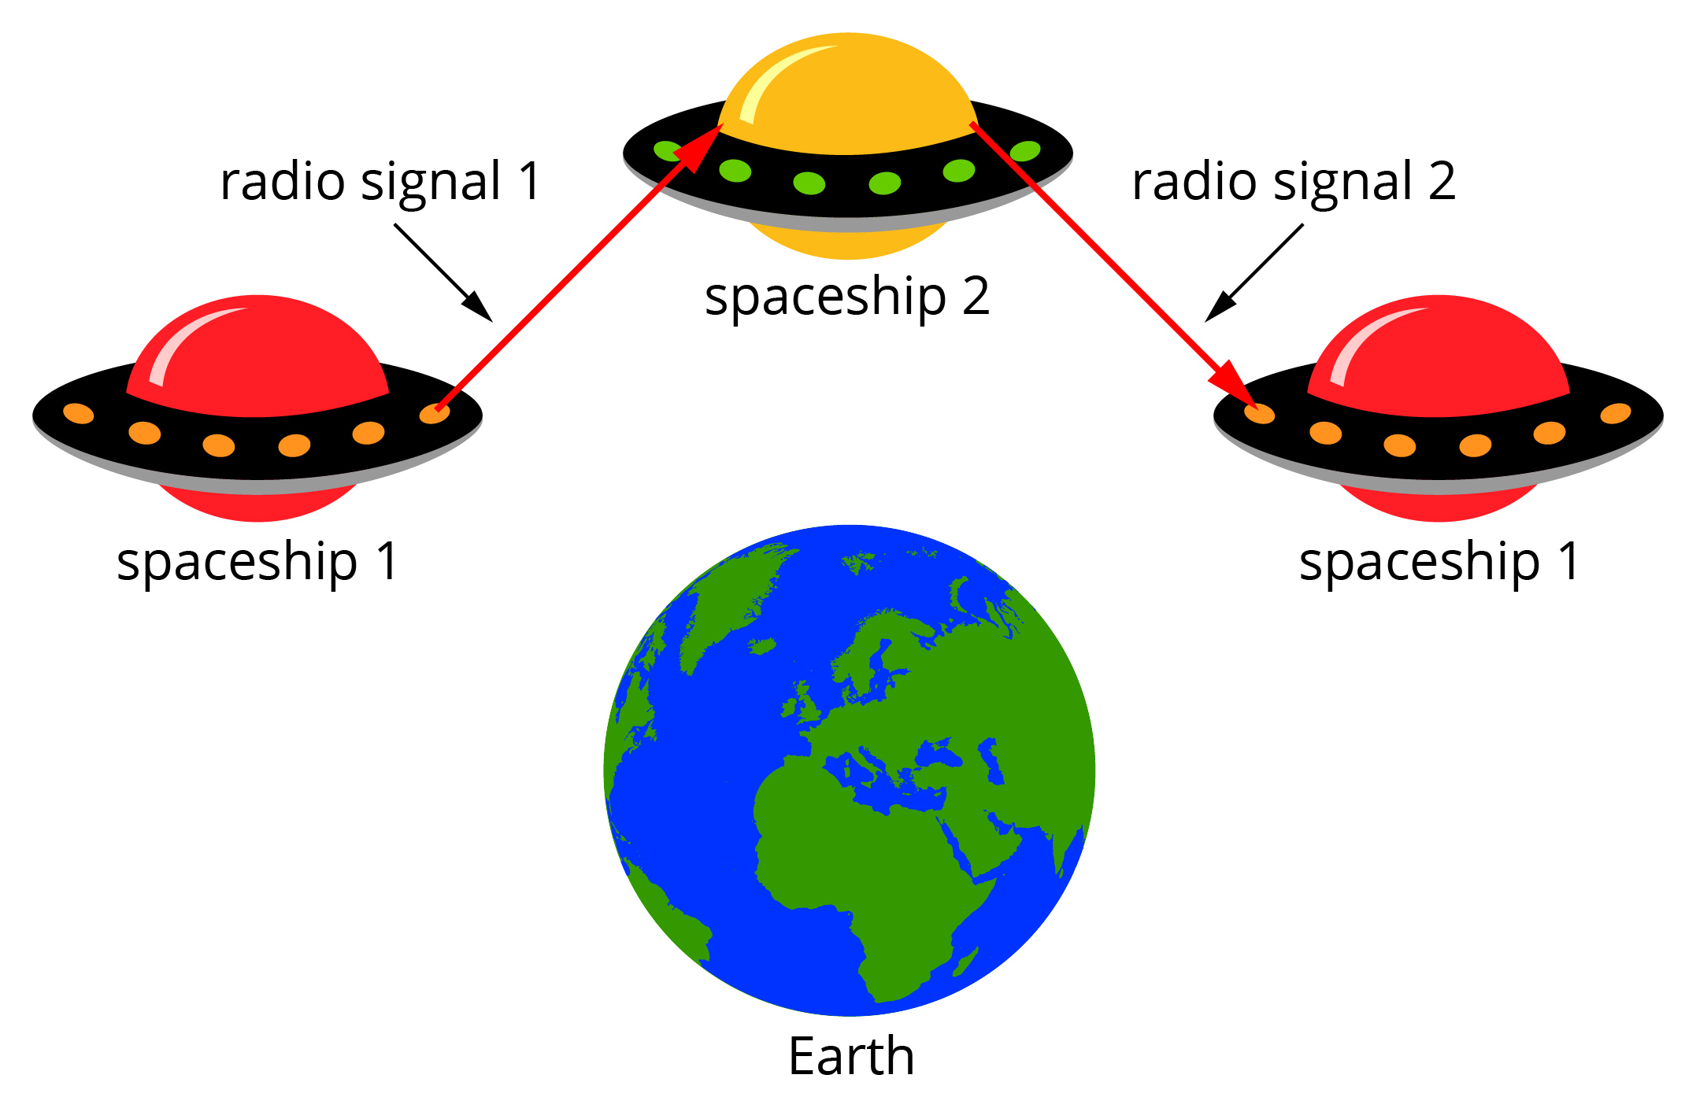
Description | Marks
Suitable diagram (such as that above) showing distance travelled by light is greater for Earth observer | 2
The signal from the perspective of the ships’ captains travels 2d, so time for signal to be sent and return is given by: | 1
From the Earth observer’s frame of reference, because the ships are moving, by the time the signal from ship 1 reaches ship 2 the distance for the light to travel from ship 1 to ship 2 is greater than d. Similarly for the return signal. | 1
If we let x be the distance from the Earth observer’s perspective, then time from the Earth observer will be:  . | 1

Question 5
a One of the pieces of evidence to support Einstein’s special theory of relativity is the observation of the half-lives of muons, which travel at speeds close to the speed of light. If the rest half-life of a muon is 2.2 × 10⁻⁶ s, what is the half-life of a muon travelling at 0.7c? (3 marks)

Description | Marks
 | 1
 | 2

b If an observer was able to travel with the muon to measure its half-life, what would be the measured half-life? Justify your answer. (2 marks)

Description | Marks
The muon’s half-life would be 2.2 × 10⁻⁶ s. | 1
This is because the observer would be travelling the same speed as the muon, so the muon would appear to be at rest. | 1
Question 6
a A comet is travelling away from Earth at a speed of 0.18c. A space probe that has been sent to observe the comet measures its long axis to be 3.2 km. When the long axis is travelling directly away from the Earth, what length will the comet appear to be from the Earth? (3 marks)

Description | Marks
 | 1
 | 2

b The comet is rotating on its axis such that the long axis is at times vertical to the Earth. What length will the comet appear to have for an Earth observer when it is in this position? (1 mark)

Description | Marks
3.2 km | 1

Question 7
A probe is being sent to a planet outside our solar system. From Earth the planet is measured to be 40 light years away. At what velocity does the probe need to travel to give a distance of 20 light years? Your answer can be expressed in terms of the speed of light (c).
(3 marks)

Description | Marks
 | 1
 | 2
Question 8
Two space probes are launched from a space station in opposite directions, each with a speed of 0.75c.
a What is the speed of the second probe relative to the first? Your answer can be expressed in terms of c. (3 marks)

Description | Marks
 | 1
 | 2

b What is the speed of the first probe relative to the second? (1 mark)

Description | Marks
−0.96c | 1

Question 9
Further evidence in support of Einstein’s special theory of relativity is the larger than expected increase in the radius of a charged particle when its velocity is increased in a magnetic field. For example, if the speed of an electron in a magnetic field of constant strength is increased from 0.2c to 0.4c, classical physics predicts the radius should increase by a factor of 2 but it is observed to increase by a factor of 2.14.
Explain this observation using the appropriate physics concepts, including appropriate formulae. Note: calculations are not necessary. (4 marks)

Description | Marks
In classical physics, radius of the electron is given by: | 1
Thus, an increase in velocity of a factor of 2 should result in the radius increasing by a factor of 2. | 1
In special relativity, the mass (or momentum) of the electron will increase as velocity increases according to: | 1
Thus, the increase in mass of the electron at the higher velocity accounts for the higher than predicted increase in radius. | 1
Question 10
A conclusion of the special theory of relativity is that no object can reach or exceed the speed of light. Explain this conclusion. (2 marks)

Description | Marks
As velocity increases, an object’s mass increases according to: | 1
Thus, at v = c mass becomes infinite and so to accelerate an object to c would require infinite energy. | 1

Question 11
A meson of rest mass 2.4 × 10⁻²⁸ kg travels at 0.85c.
a Calculate the meson’s kinetic energy at this speed. (4 marks)

Description | Marks
Mass of meson at 085c: | 2
E_{k} = γm_{o}c² − m_{o}c² | 1
E_{k} = (γm_{o} − m_{o})c² = (4.56 × 10⁻²⁸ − 2.4 × 10⁻²⁸)c² = 1.94 × 10⁻¹¹ J | 1

b If while travelling at this speed the meson decays completely to electromagnetic radiation, what energy is released with the radiation? (2 marks)

Description | Marks
E_{t} = γm_{o}c² | 1
E_{t} = γm_{o}c² = 4.56 × 10⁻²⁸ × (3 × 10⁸)² = 4.1 × 10⁻¹¹ J | 1

